Wo’okihi: People must actively participate in the development of one's own potential.
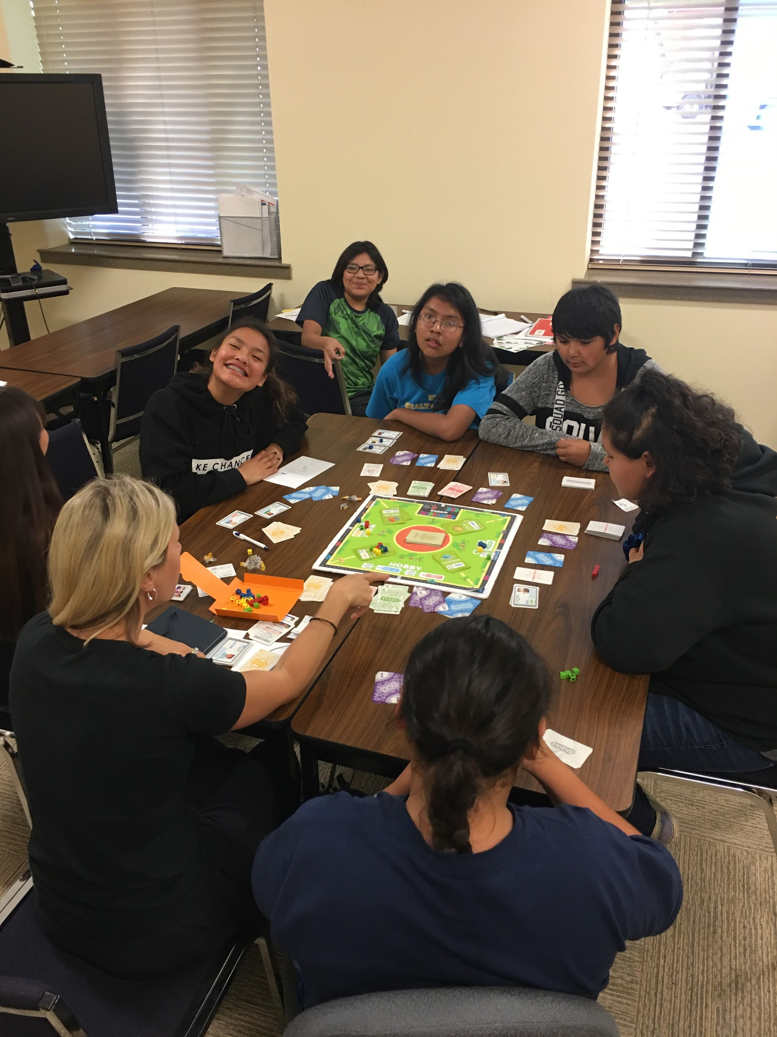 | Exploring your options for the future  What things must you explore before Applying for college?  *  *  *  What will I learn from “Xello”?  Will I learn to choose a career suited to my preferences?  Can I change my mind?  What are my options?  Will it help me create a plan?  Will Xello reassess my plans if I change my mind?
What is a FAFSA?
What kind of information must I provide?
Am I ready for college?
What questions do I still have before I make a decision about college?
So many options…

Where do I begin?
Do I want a 4-year college degree?
Do I want to attend a trade school?

Reflect on your future,
What are your thoughts at this time?

What questions do you have?

